Customer Onboarding Checklist

Welcome to improveit 360!
We are happy to have you! Included in this document is a basic list of onboarding tasks each new customer will be completing in preparation for Go-Live. This is simply one of the tools at your disposal to guide a great onboarding experience. The checklist aligns to the In-App Guidance right within your new system, as well as the onboarding sessions you will start scheduling with your Solution Consultant.

Training and Onboarding Process
To make the set-up and configuration of your new improveit 360 platform easy, and training a breeze, adherence to our defined onboarding process is strongly recommended. Our process is designed to expose you to your new application in small bit-sized chunks. Phase 1 of your onboarding includes 6-8 collaborative sessions to train you on the managed package and complete basic setup items.

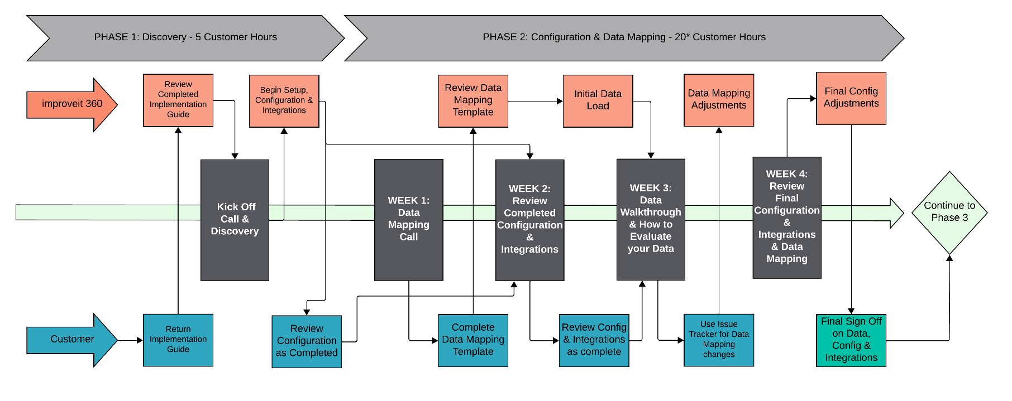
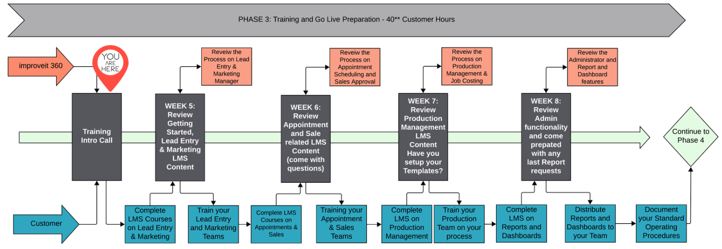
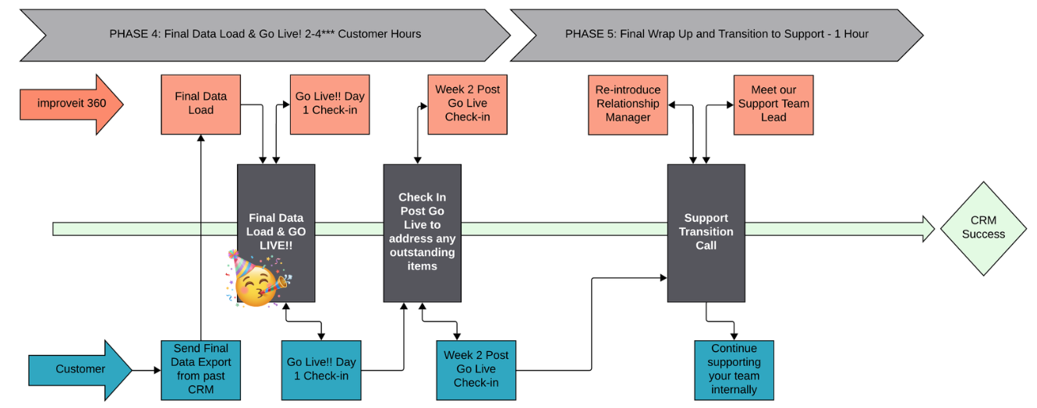
Your Onboarding Checklist
Steps to Success! - Action Items | Additional Details |  | Quick Reference Documentation | Need for i360 to help? | Date completed
TRACK YOUR PROGRESS. ENTER THE DATE COMPLETED AS YOU FINISH EACH THEM
Login & Bookmark the Login Page. Save your Login Credentials someplace safe and easy to access. | improveit 360 does not recommend using a Microsoft web browser. The best login page is always:  https://login.salesforce.com/ |  | Login and Bookmark the Login Page | NA | Do it TODAY!
Access improveit 360 App and complete the Home page Walk-thru | Be ready to help other Users Login and navigate to the App for their first time! | Our in-app Home page Walk-thru will guide you through the basic system navigation. | Account Page Video Walk thru | NA | Enter Date Completed
Review Quick Lead tool, the Glossary of Terms and Object diagram but don’t create new Leads just yet! | Review the required fields when creating a new Contact, Account and Sales Opportunity for a foundational knowledge of the platform. | Glossary of Terms by Object  and  Object Relationship Diagram | Lead Entry | NA | Enter Date Completed
Review Lead Source’s “Source” and "Source Type" and deactivate ones you will not be using | Configuring Source Types assures you can track broad marketing spending as well as individual efforts. | If converting Data, wait until Data is loaded before editing Sources and Source Types | Set Source Type and Source Values for Lead Sources | NA | Enter Date Completed
Create Lead Sources / End Past Lead Sources | Lead Sources are in individual ways in which you advertise. Ex:  Source Type: Internet Source: Facebook Lead Source: Facebook Spring ‘23 campaign | If converting Data, wait until Data is loaded before adding Lead Sources | Creating Lead Sources and Ending Lead Sources | NA | Enter Date Completed
Setup Global Product Categories | These names are how the system determines sales reps when Scheduling, or Project staff on the calendar. | If converting Data, wait until Data is loaded before setting Product Category values. | Set Global Product Categories | NA | Enter Date Completed
Setup Territories | Territory is the general markets or geographic region where you sell and install your products. Some companies may work in only one Territory. | If converting Data, wait until Data is loaded before editing Territory values. | Set Global Territory Values | NA | Enter Date Completed
Setup Organization Wide Email Address | This is the email address where any automated emails will come from. (Reply to) |  | Set Organization Wide Email Address | NA | Enter Date Completed
Setup Company Information - Address Phone Time Zone | This contact info will appear on Email Templates and documents like Quotes & Invoices |  | Set Company Information | NA | Enter Date Completed
Setup Fiscal Year (if applicable) & Define Business Hours | If your Fiscal Year does not begin in January, be sure to set the starting month for your Fiscal Year. | Define your company’s Business Hours to ensure you are not scheduling outside of normal operating hours. | Set Fiscal Year and Business Hours | NA | Enter Date Completed
Upload Company Logo | This logo will appear on Email Templates and documents like Quotes & Invoices |  | Upload your Company Logo | NA | Enter Date Completed
Review Staff records and End Former Staff | If converting Data, wait until Data Conversion is completed before adding Staff | If converting Data, wait until Data is loaded before adding Staff to your system. | Ending Staff members and Deactivating Users | NA | Enter Date Completed
Review Standard User Profiles/ Determine if Profiles suit Usership | Determine if any Custom User Profiles are needed before Activating the User | Review the OOB Profiles included with the Lightning platform. | User Profile Settings | ☐ | Enter Date Completed
Activate Key Users (Department Heads) | Allowing a select group of Users (your Management Team) access now will help better determine Configuration needs |  | Creating Staff and Activating Users | NA | Enter Date Completed
eLead Integration Setup (if applicable) | Having leads come directly into improveit 360 allows you to jumpstart marketing efforts |  | eLead Endpoint Setup  eLead HTTP Post via Query Parameters | ☐ | Enter Date Completed
Activate Matching Rules or create your own | Matching Rules are used to prevent duplication of Leads, Customers and Accounts in your system. |  | Standard Matching Rules for Account and Contact | ☐ | Enter Date Completed
Intro to Accounts, Contacts, Sales Opportunities & Task List Views | Configured List Views are the best way to find Contacts or groups of contacts which need to same type of action. | (refresh your memory on) Glossary of Terms by Object | (recap) Lead Entry  List View Guide | ☐ | Enter Date Completed
Review Result Details and Appointment Status and Status Detail fields | Capture reasons why an appointment did not sell and automate reminds for you to call the Contact again. |  | Editing Picklist Values and Working with Dependent Picklists | ☐ | Enter Date Completed
Setup Lender and Vendor Accounts | When tracking Loans or Creating Purchase Orders and Products, you'll need to setup Lenders and Vendors |  | Create Lenders & Loan Options | NA | Enter Date Completed
Create your Products Database and setup Quote Templates | Before your team can create Quotes and Sales, you’ll need to enter the individual Products you sell.  *At a minimum you should have one Product for each Product Category. |  | Working with Products and Quote Templates | ☐ | Enter Date Completed
Appointment Scheduling Settings – Time Block Calendar vs Scheduling Calendar | Your Team has two options when scheduling Appointments. Review both methods and determine your appropriate internal process. | Using Time Blocks and the Time Block Calendar | Appointment Scheduling using the Scheduling Calendar | ☐ | Enter Date Completed
Review the Quote creation process and how to Result into a Sale | What does your company include on a Quote? Is it itemized or a lump sum? | Rescheduling and Resulting Sales Appointments | Creating a Quote and using Quote Templates | ☐ | Enter Date Completed
Define Sales Approval Process & Create or Edit Sale Status Details & Create Sale List Views | When is the handoff from Sales to Production? Configure improveit 360’s Approval Process to match your internal processes. |  | Sale Status and Status Detail | ☐ | Enter Date Completed
Review the Payment Processing information. Decide if you will use automated payments in i360. | improveit 360 integrates with PaySimple for real-time payment processing. In addition, your team can log payments in i360 without any integrations at all. | PaySimple payment processing & Payment Links to request payments | Apply Payments to Sales and Projects | ☐ | Enter Date Completed
Review Loans and Loan Options | Loan records can help track finance agreements with Lenders and ensure your team follows up on Approved Loans when the Contact didn’t move forward with their purchase. |  | Adding Loan records to Quotes and Sales | ☐ | Enter Date Completed
Create Project Templates | Project Templates streamline your production process using step dependency. |  | Creating Project Templates and Project Template Activities | ☐ | Enter Date Completed
Create Project and Project Activity List Views | Configured List Views are the best way to give your Staff a list of tasks to work through each day. Practice creating Projects and tailoring List Views |  | Locating Sales without a Project, Create the Project and apply a Template | ☐ | Enter Date Completed
Review OOB Reports & Dashboards - Identify any Custom Report needs | improveit 360 comes with 15 Reports and 1 Dashboard, ready to use Out-of-the-Box |  | Reports and Dashboard Guide | ☐ | Enter Date Completed
Building Reports in Lightning Report Builder | Report Types determine which Data is queried in a Report.  Practice modifying existing Reports by changing Date Range, Grouping or Sort Order. |  | Report Types  Change Date Range, Grouping and Sort Order | NA | Enter Date Completed
Report Formulas vs Formula Fields | Because the Lightning Report builder allows you to create Formulas at the row-level, there are fewer use-cases for Formula fields on the object. |  | Creating a Formula Field on a Report | ☐ | Enter Date Completed
Review OOB Email Templates - Customize the Wording | improveit 360 comes with 6 Contact-facing Emails and 4 Staff-facing Emails Out-of-the-Box |  | Lifecycle Email Communications Guide  Edit your Email Templates | NA | Enter Date Completed
Setup > Flows | Your Administrator User can turn on and off your automated Emails from the Flows menu |  | How to Activate or Deactivate Email Automations | ☐ | Enter Date Completed
Activate Secondary Users! | Once appropriately configured, you're ready to give the rest of your Users access to the system and conduct General User Training. |  |  | NA | Enter Date Completed
Go Live! | Work directly with our Onboarding Team on the day of Go Live to ensure a smooth successful transition for your team! |  |  |  | SET THE DATE!
Get ready for CRM greatness!

